COMHAIRLE CHONTAE AN LONGFOIRT

LONGFORD COUNTY COUNCIL

Please note Time of Meeting - Corporate Affairs,
5.00 p.m. Aras an Chontae,
LONGFOIRT.

10u Meitheamh 2015.

Chuig: Gach Ball don Chomhairle.

A Chomhairleoir,

Iarrtar ort bheith i láthair ag Cruinniú Ginearálta Bliantúil Chomhairle Chontae Longfoirt a tionólfar i i Seomra na Comhairle, Longfoirt ar an Chéadaoin
17ú Meitheamh 2015 ag 5.00 p.m chun gnó a dhéanamh d’réir an Chláir thíos.

You are requested to attend the Annual Meeting of Longford County Council to be held in the Council Chamber, Aras an Chontae, Longford on Wednesday,
17th June 2015 at 5.00 p.m. to transact business, as set out on the Agenda hereunder.

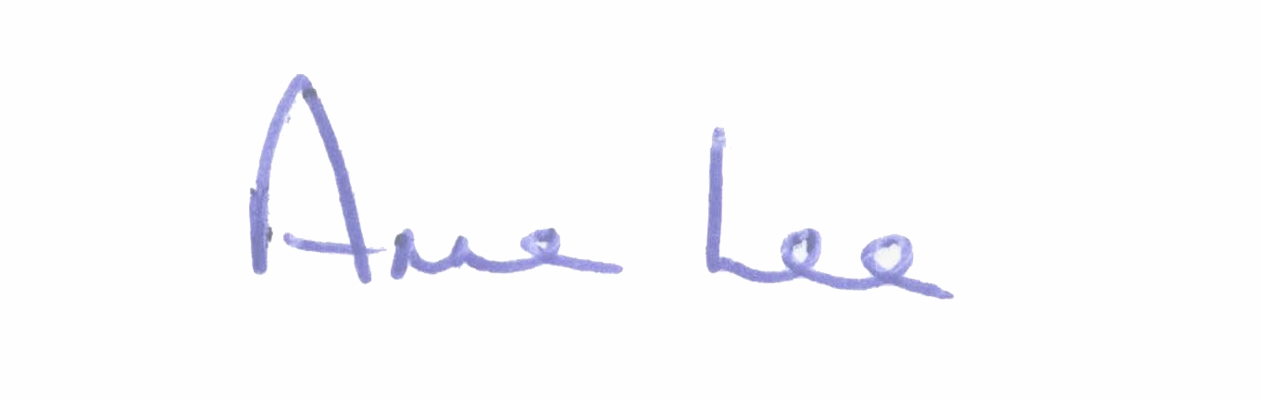
Mise le meas,

_______________________
Anne Lee,
Meetings Administrator.

C L A R

Prayer before Meeting.

- Election of Cathaoirleach.

- Election of Leas Cathaoirleach.

- Fix date and time of meetings.

:::::::::::::::::::::::::::::::::::::::::::::

